Assignment 3 Tobias Axelsson

911217-4116  
tobaxe-2@student.ltu.se

# Step 1

Installing Virtualbox per se was not hard, but I ran into a problem in step 2 which I tried to solve by reinstalling Virtualbox several times.

# Step 2

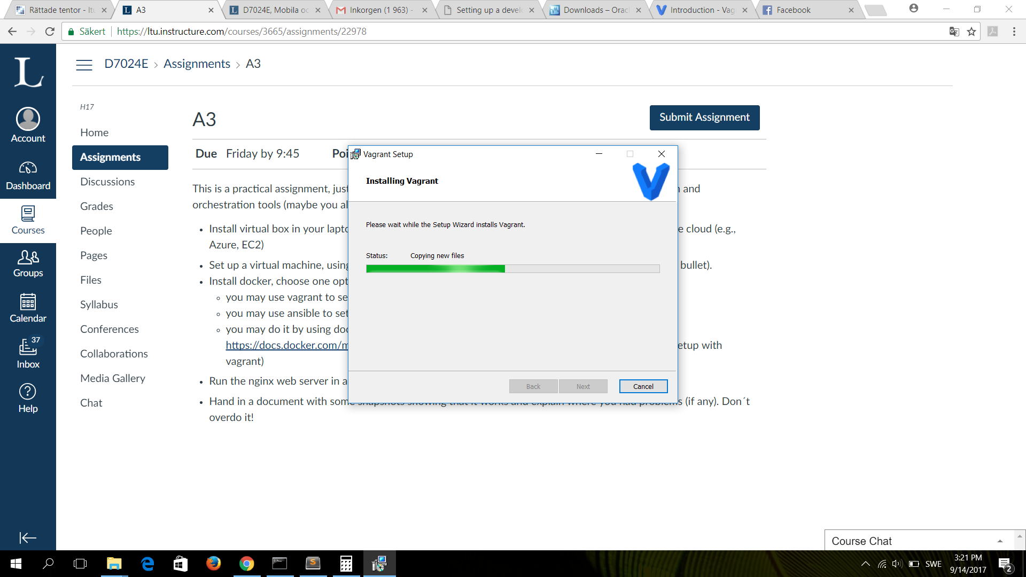

Once Vagrant was set up I installed the hashicorp/precise32 box and tried to run it. I ran into trouble here when I tried to boot the VM. It would stuck each time on the same place as shown in the picture below.

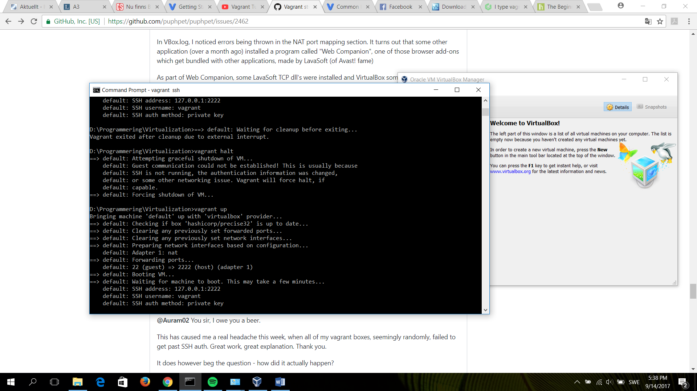

Eventually I got it up and running:

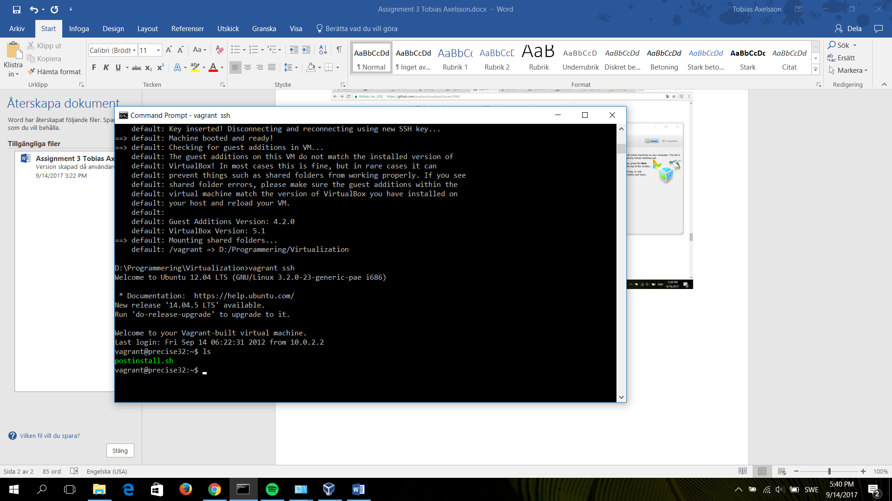

# Step 3

I tried using Vagrant but had trouble installing docker for some reason. In the end I used the toolbox instead to set up the web server:

